**Richard’s Supply**

The SQL files to be used.

1. **1_DDL_Case Study**
2. **2_Data**
3. **3_Data Constraints**

“Richard’s Supply” is a company which deals with different food products. The company is associated with a pool of suppliers. Every Supplier supplies different types of food products to Richard’s supply. This company also receives orders for the food products from various customers. Each order may have multiple products mentioned along with the quantity. The company has been maintaining the database for 2 years.

Refer to the following Entity-Relationship diagram of the database.

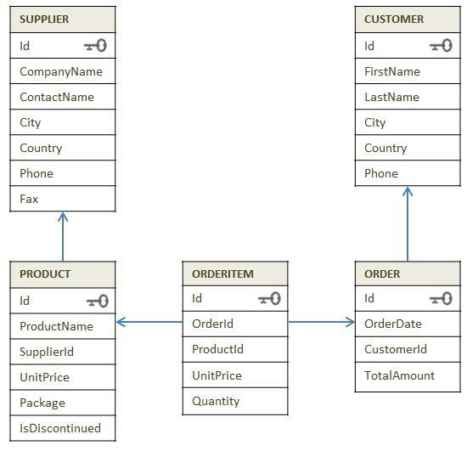

Diagram: E-R Diagram of Supply_chain database

**Tasks to be performed:**

1. Company sells the product at different discounted rates. Refer actual product price in product table and selling price in the order item table. Write a query to find out total amount saved in each order then display the orders from highest to lowest amount saved.
2. Mr. Kavin want to become a supplier. He got the database of "Richard's Supply" for reference. Help him to pick:

a. List few products that he should choose based on demand.

b. Who will be the competitors for him for the products suggested in above questions.

1. Create a combined list to display customers and suppliers’ details considering the following criteria

* Both customer and supplier belong to the same country
* Customer who does not have supplier in their country
* Supplier who does not have customer in their country

1. Every supplier supplies specific products to the customers. Create a view of suppliers and total sales made by their products and write a query on this view to find out top 2 suppliers (using windows function) in each country by total sales done by the products.
2. Find out for which products, UK is dependent on other countries for the supply. List the countries which are supplying these products in the same list.
3. Create two tables as ‘customer’ and ‘customer_backup’ as follow -

**‘customer’ table attributes** -

Id, FirstName,LastName,Phone

**‘customer_backup’ table attributes** -

Id, FirstName,LastName,Phone

Create a trigger in such a way that It should insert the details into the ‘customer_backup’ table when you delete the record from the ‘customer’ table automatically.